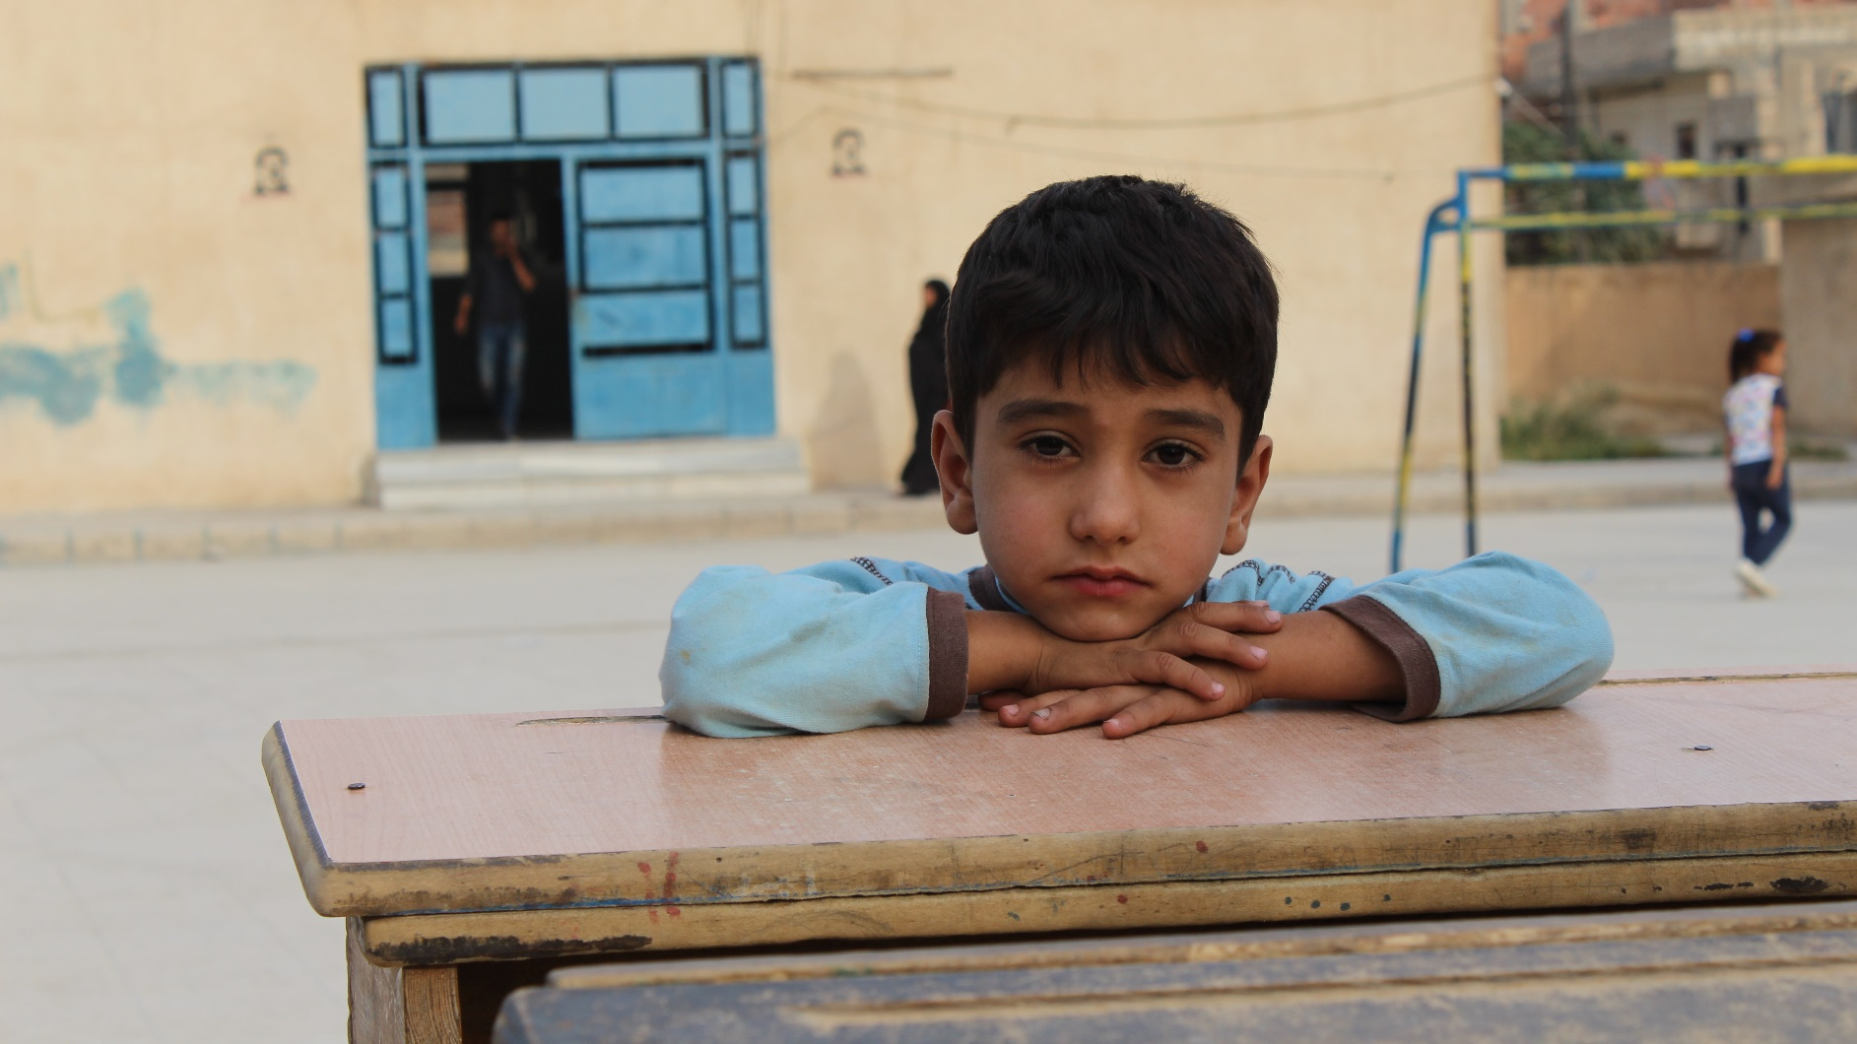
A young Syrian boy displaced by fighting in northeast Syria waits outside a school in the Hakaseh Governorate. His family is among those who fled the escalation of violence and took shelter at the school. Save the Children Photo

War-Affected Children and Families
Depending on a Lifeline of Humanitarian Aid
Syria’s Crisis:

Urgent Request for Support
October 16, 2019

Executive Summary
The intense and increasingly complex conflict in northeast Syria is creating fresh waves of displacements – the UN’s Office for the Coordination of Humanitarian Affairs reported that as of October 14, at least 160,000 children and adults had fled indiscriminate airstrikes, shelling and ground combat. Many of them had already been displaced from their homes at least once during Syria’s ongoing war. They are crowding into camps and shelters that are unprepared to provide food, clean water, hygiene and sanitary facilities, access to basic services and weatherproof shelter for the fast-approaching winter.

Save the Children, which has worked inside Syria since 2012 and has programs and partners operating in some of the most turbulent and insecure areas, has delivered medicine to newly opened shelters in the northeast. We are procuring food and supplies children will need to fend off winter’s cold. We are continuously monitoring events so that we can mobilize additional aid to those on the move.

The fighting is adding even greater weight to Syrian’s ongoing humanitarian crisis resulting from eight years of constant conflict. We are urgently seeking funding that will not only underpin our planned responses in the northeast as security allows, but our “whole of Syria” work for other children who are in dire need of support and access to services including health care, education and psychosocial support for the trauma they have experienced.

Your generous contribution to our Syrian Children’s Relief Fund will leverage a range of work to alleviate suffering and restore hope to children weary of war. The Relief Fund’s flexible, immediately accessible resources help sustain our rapid relief to scenarios such as the fighting in the northeast and the daily work of our humanitarian teams and partners elsewhere in Syria. Thanks in part to the Relief Fund and the donors who support it, our full-scale mission in Syria has helped meet the critical needs of over 3.1 million Syrians.

Your compassion has never been more important to children in the crossfire in northeast Syria, and as well for other girls and boys who depend on the lifeline of our Syrian Children’s Relief Fund. Thank you.

The Crisis at a Glance
The rapid escalation of fighting in northeast Syria has triggered an exodus of tens of thousands of children and adults. While numbers cannot be verified given the fighting and constantly changing conditions, the UN’s Office for the Coordination of Humanitarian Affairs reported that as of October 14, at least 160,000 people were displaced by air strikes, shelling and ground assaults. Our staff report that entire villages and camps of families who had fled previous conflict are now empty.

Since the beginning of the offensive, shelling and air strikes have occurred along the entire northeast Syria border with Turkey, affecting densely populated cities like Al Hassakeh and Qamishli. The water situation in Al-Hassakeh and its surroundings is becoming critical, as damage to a water treatment plant has cut service to over 400,000 people, leaving them with no drinking water.

The full humanitarian impact of the current fighting is difficult to determine, as the situation remains volatile. However, mass displacements such as this not only create immediate needs of food, shelter, water and access to basic services for those on the move, but also instil fear and confusion among children who have been exposed to indiscriminate shelling and air strikes. Schools are closed or in use as temporary shelters, leading to disruptions in children’s education.

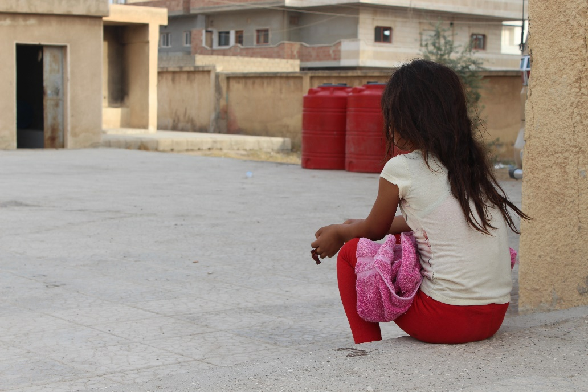
The situation in northeast Syria is adding even more strain to the country’s vast humanitarian crisis brought about by eight years of conflict. The lives and well-being of millions of children and their families remain in jeopardy, and a generation of Syrian girls and boys has had their childhoods shaped by war.

- In the northwest, hostilities have displaced more than 400,000 people since late April of this year. Many children and families have been displaced multiple times already – they have taken refuge on the sides of roads or in fields, making tents by stringing sheets between trees. Nearby camps are beyond capacity, and some camp populations have quadrupled following this upsurge in violence. It is estimated that there are over 1.5 million internally displaced persons in the northwest.
A young girl, one of the tens of thousands of people displaced by the conflict in northeast Syria, sits alone in a schoolyard where families have taken refuge.
Save the Children Photo

- The overcrowded camps and settlements put children at risk of diseases and expose them to abuse and exploitation. Cold winter winds and precipitation leave children in these places bone-chilled and sick with colds.
- Across the country, 11.7 million people are in need of humanitarian assistance, including over 5 million children.
- Out of sheer desperation, many girls and boys are being married off at a young age and withdrawn from school by their families to work, often in dangerous conditions. This toxic environment leaves many girls and boys deprived of their psychosocial needs and in a position of profound and prolonged distress.
- Although government-held areas are relatively stable, many obstacles remain for people to return to their homes. These include concerns over safe and free movement, fear for renewed violence; inability to rebuild or repair homes and the lack of livelihoods and other basic services.

Our Humanitarian Response Inside Syria
Save the Children has worked relentlessly inside Syria since 2012 to alleviate the needs of conflict-affected children, including in the northeast. To date, working with and through partners, this work has benefited 3.1 million people, of whom 2 million are children.

In the past week, our teams have provided medicines to shelters that have opened in the northeast for those fleeing the fighting. We are procuring supplies children and families will need for the approaching winter, including warm clothing and blankets. Supplies of ready-to-eat food are also being procured and we expect to deliver them in the next several days.

We visited three school where displaced families are staying to provide “psychosocial first aid” to help them deal with the stress of suddenly being on the front line of war and the turmoil of displacement. We’ve counselled pregnant women and nursing mothers about the importance of breastfeeding and have started to screen children for signs of malnutrition. Several children who were malnourished were referred to a local agency that provides nutritional services.

Our teams are assessing conditions constantly and, contingent on security and accessibility, are prepared to move quickly to support more children and families in shelters in the city of Al Hasakeh and in the Areesha camp, where we have longstanding programs. We are also assessing other opportunities to work with partners on responses as conditions allow.

Elsewhere inside Syria, our teams and partners continue to address such urgent needs as shelter, food, water and hygiene, health care, emergency education and protecting children traumatized by the war from further emotional harm. We have also provided families with cash vouchers that enable them to decide what materials they need the most.

We support health facilities and a maternity hospital that treat thousands of people every month. We also support early childhood development centers, temporary learning spaces and informal schools. In 2018, we reached18,000 displaced children and adolescents with quality basic education. To help children survive winter’s freezing temperatures and storms, we provide warm clothing, blankets and heaters.

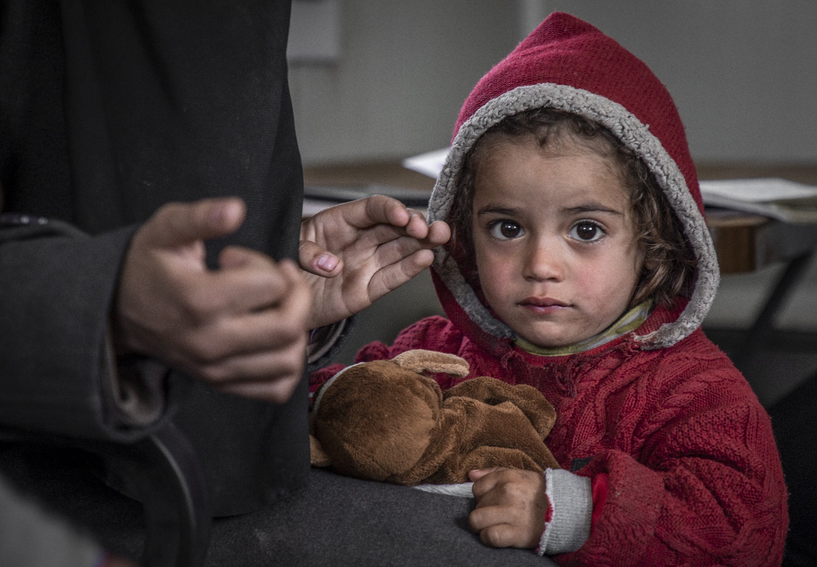
Through advocacy, we also make sure that Syrian children’s voices and needs are heard. For the third Brussels Conference on Supporting the Future of Syria and the Region in March, we surveyed hundreds of Syrian girls and boys about their challenges and hopes for the future. We compiled their voices and stories into a report, A Better Tomorrow: Syria's Children Have Their Say. In May, we launched the Stop the War on Children campaign with an advocacy event at The Hague. Our Stop the War on Children Charter forms the basis for a safer future for children in Syria and other conflict-affected areas.
We provide a range of support to displaced Syrian families. Earlier this year Tamer, 4 and his mother Yasmine received blankets, mattresses and hygiene supplies. We also provided the family with access to medical care.
Save the Children Photo

The Urgent Need for Your Support
While our donors have generously funded our lifesaving programs inside Syria from the beginning, the enormity of needs there and the sudden displacement of people fleeing the intense fighting in the northeast further stretches our capacity to respond.

Your contribution to our Syrian Children’s Relief Fund will provide our teams with the funds to mobilize quickly when children and families flee for their lives because shelling, airstrikes and ground assaults have put them in the crossfire. The flexibility that the Relief Fund provides also gives us the capacity to scale up ongoing work or respond to new needs, such as improving access to health care and restoring children’s access to education.

As the rapid and changing context in Syria unfolds, we are prepared for scenarios that will require us to tap the Relief Fund. The following are examples of ongoing and recent activities that it supports.
The Syrian Children’s Relief Fund
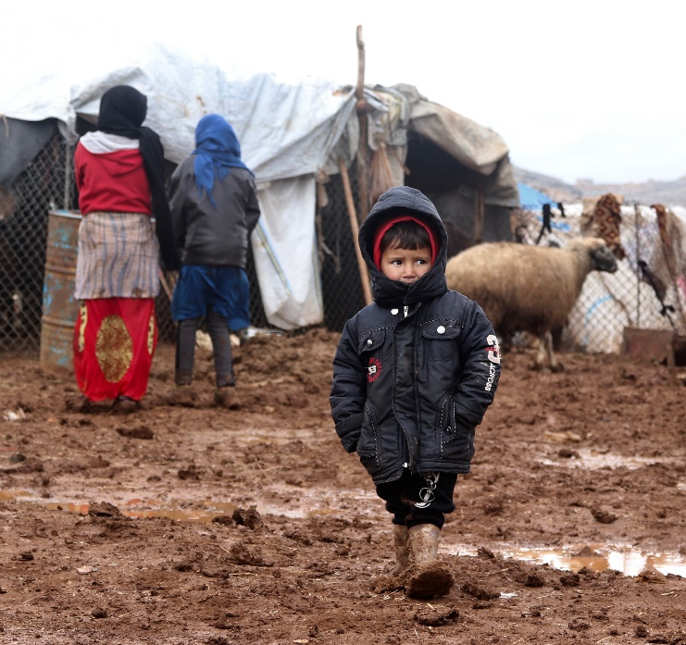
- Since 2012, the Fund has exclusively supported our work for Syrian children and their families.
- So far this year, it has helped reach over 230,000 of the most marginalized and vulnerable Syrians with food, health and nutrition services, psychosocial support, family reunification, child protection and cash assistance.
- Since the start of the crisis, we have delivered life-saving aid and services to over 3 million Syrians, including 2.1 million children.

Rapid Relief
These allocations help to cover the most urgent and critical needs of displaced families and children, such as food, shelter, winter clothing and blankets, access to medical care and hygiene and sanitation.

Health and Nutrition Programming
With our partner, Syria Relief, we address primary and emergency health needs and care for infants, children and women who are malnourished. We support a primary health center in Al-Jeneh and two nutrition centers in Al-Jeneh and Abeen in Western Aleppo. The primary health facility includes an obstetric and gynecological clinic, a pediatric clinic, an internal medicine clinic and a 24/7 delivery room. It also offers services to prevent and treat diseases, family planning, vaccinations, laboratory services and wound dressing.

Ensuring children’s nutrition needs are met in humanitarian crisis is critical to preventing children from becoming malnourished and more vulnerable to illness and death. We support two nutrition centers that screen and treat infants and young children for malnutrition.

Nutrition staff provide guidance to women on the importance of breastfeeding, complementary feeding practices and information on how to manage breastfeeding during the most difficult and stressful time of these mothers’ lives. Community health workers also provide health and nutrition services to families in the communities surrounding the clinics.

Expanding our Reach
“
Humanitarian needs still persist in the south and central areas of Syria, a government-controlled region, and our goal is to expand our programs as there are few other aid agencies on the ground. We have used the Fund to build community partnerships with groups that will help us deliver important nutrition, inclusive education and child protection programs.
The reports of civilian deaths, including those of two children, and several more injured are devastating. North East Syria is home to people who are all too familiar with the horrors of war. How many times have we seen women and children with their belongings bundled on their backs, moving in search of safety? With winter around the corner, they will face additional challenges as they search for shelter. Families are worried about their lives. They cannot think of anything else but getting their children to safety.
--Save the Children staff in northeast Syria
Conclusion
Fighting in the northeast of Syria has emptied villages and communities as families flee for their safety, carrying only what they have the strength to. Some families have fled fighting at least once before, creating even more chaos and trauma in their children’s lives.

Our presence in Syria and our partners position us to quickly mobilize relief as security allows, and our assessments and close monitoring will inform our programming as the crisis unfolds. However, the deteriorating conditions in the northeast is straining our capacity to respond to children and families there, while simultaneously sustaining other critical and ongoing programs reaching thousands of war-weary girls and boys.

Our Syrian Children’s Relief Fund gives us the ready resources for starting, sustaining and scaling humanitarian work across Syria as crises within the war occur. Your contribution to the Relief Fund will make our Syria presence and programs even more effective, and increase children’s chances of surviving and recovering from their nightmare of adversity.

